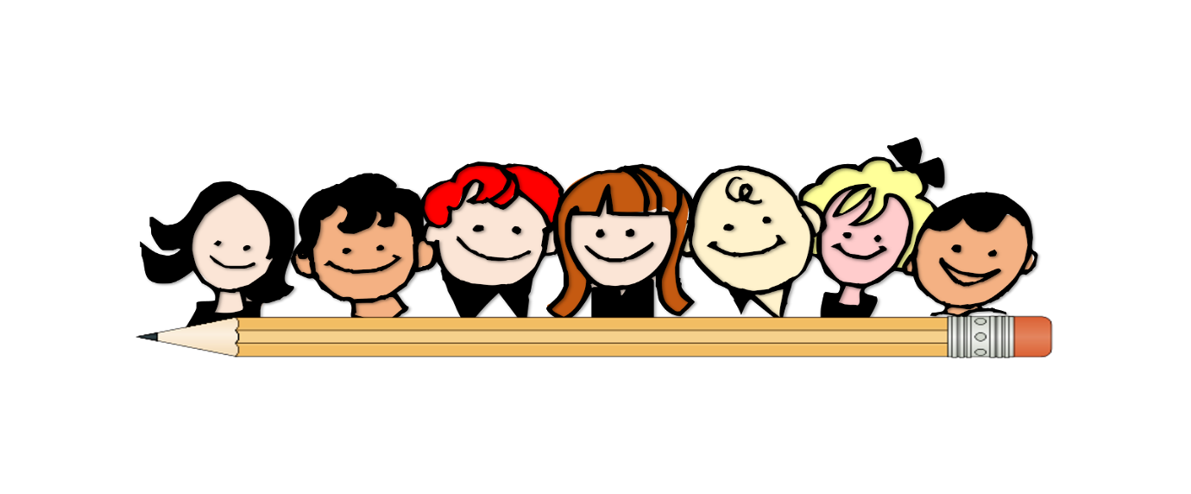
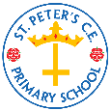

Summer 1 Year 1 Curriculum Overview
Learning
This is what we will be learning this half-term:

Parent/Carer Reminders and Diary Dates
- Children need to come to school on their PE day (Friday) wearing a full PE kit: navy or blue jogging bottoms, plain white polo, plain trainers or pumps
- Maths homework goes out on a Thursday and is due in on a Wednesday. Spellings go out on a Monday.
- Children should be accessing IXL at home. See the class teacher if you are unsure of your password.
- It is imperative that you know how to access Google Classroom in case your child’s year are sent home to isolate. Please speak to the class teacher if you are still unsure how to access or look on our website in the ‘Covid’ tab.
- Children should be reading at home every night but we have a minimum expectation of 4 times a week. Please ensure your child’s book is signed by an adult.
- We do not allow bags in school. St.Peter’s book bags can be ordered from:
www.myclothing.com
www.pbuniform-online.co.uk/stpetersprimary
A REMINDER THAT SCHOOL IS CLOSED FOR VOTING ON THURS 6TH MAY AND FOR INSET ON MON 7TH JUNE
Hope Honesty Compassion
1John 3:18 Dear children, let us not love with words or speech but with actions and in truth.

English | Maths | PSHE Heartsmart | History
Room on the Broom (simple narrative retell) and Jack and the Beanstalk (traditional tales retell) | Place value within 50.  Measurement (weight and height, length and volume) | Fake is a mistake! Why is it important for me to do me? | ‘Take Flight!’  Learning about early aviators eg The Wright Brothers, Amelia Earhart and Charles Lindbergh.

