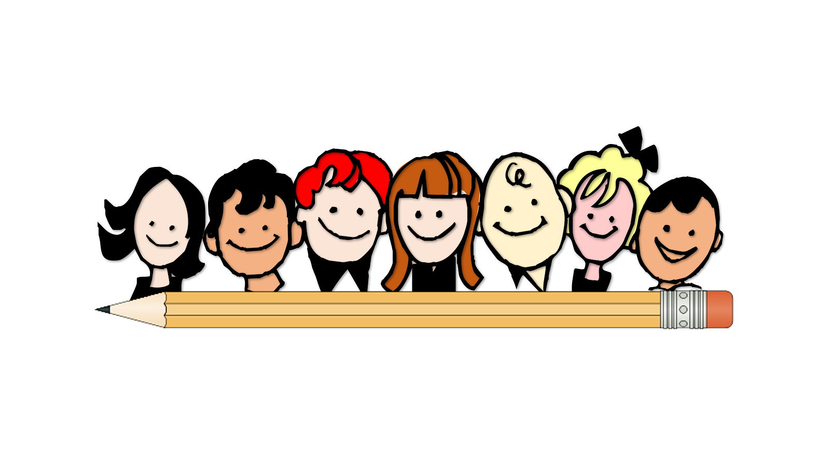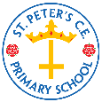

**Summer 1 Year 2 Curriculum Overview**

**Learning**

This is what we will be learning this half-term:

|  |  |  |  |  |
| --- | --- | --- | --- | --- |
| **English** | **Maths** | **PSHE Heartsmart** | **Science** | **History** |
| Beegu  (Letters)  A place called home (narrative) | Application of the four operations of number and measures | Fake is a mistake! Why is it important for me to do me? | Growing plants | Sir Robert Peel |

**Parent/Carer Reminders and Diary Dates**

* Children need to come to school on their PE day wearing a full PE kit: navy or blue jogging bottoms, plain white polo, plain trainers or pumps
* Homework goes out on a Thursday and is due in on a Wednesday: Times tables, spellings/phonics and maths
* Children should be accessing Times table Rockstars, IDL or IXL at home. See the class teacher if you are unsure of your password.
* It is imperative that you know how to access Google Classroom in case your child’s year are sent home to isolate. Please speak to the class teacher if you are still unsure how to access or look on our website in the ‘Covid’ tab.
* Children should be reading at home every night but we have a minimum expectation of 4 times a week. Please ensure your child’s book is signed by an adult.
* We do not allow bags in school. St.Peter’s book bags can be ordered from:

[www.myclothing.com](http://www.myclothing.com)

[www.pbuniform-online.co.uk/stpetersprimary](http://www.pbuniform-online.co.uk/stpetersprimary)

**A REMINDER THAT SCHOOL IS CLOSED FOR VOTING ON THURS 6TH MAY AND FOR INSET ON MON 7TH JUNE**

***Hope Honesty Compassion***

***1John 3:18 Dear children, let us not love with words or speech but with actions and in truth.***

