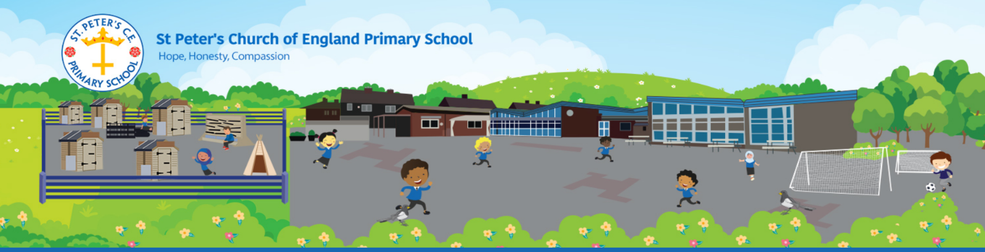
NEWSLETTER – APRIL 2021
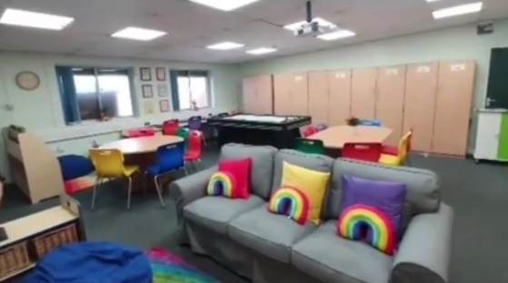
RAINBOW ROOM
The Rainbow Room is officially up and running for our after-school club and interventions. Please contact the school or look at our website for the information about wrap around care available at St. Peter’s – Places currently available.

CURRICULUM OVERVIEWS
Class curriculum overviews are now available of our school website.

BIRTHDAY TREATS & SWEETS
Moving forward, we are happy for children to bring individually wrapped sweets on their birthday for their class, if they wish.

WARMER WEATHER
As we hopefully begin some warmer weather we would like to ask that you apply sun cream to your child(ren) before sending them to school, when needed. They are also allowed to bring a cap or sun hat to wear whilst outside. In addition, we also ask that you send your child in with a water bottle each day as we are unable to use the water fountains at the current times.

COVID RESTRCITIONS
In line with our Covid-19 risk assessment please remember when dropping off/collecting or visiting school to wear a face mask unless exempt.

IMPORTANT DATES
3rd May | Bank Holiday
6th May | Election Day - School Building Closed
11th May | Reception & Y6 – Height and Weight
28th May | School Closes 3:15pm
8th June | School Opens
14th June – 18th June | Assessment Week
21st July | School Closes 3:15pm
2nd September | School Opens

