**Reception Summer 1 Curriculum Overview**

**Reach for the Sky**

**Physical Development**

* Keeping Healthy
* Health & body awareness – personal hygiene
* Outdoor Area – showing control in large movements.
* Scissor skills – showing control in small movements.
* Play dough and other fine motor activities
* Painting
* Finger gym
* Using the correct grip with a pen or pencil
* Forming recognisable letters using pre-cursive formation.

**Personal, Social & Emotional Development**

* Talk about our feelings with others.
* Understand how we should behave.
* Talk about consequences of our behaviour.
* Try new activities and say why we do or do not like them.
* Share our ideas with adult and our friends.
* Say when we do or do not need help with an activity.
* Play cooperatively and share.
* Develop narratives and stories with our friends. Ensuring we are listening to their ideas.

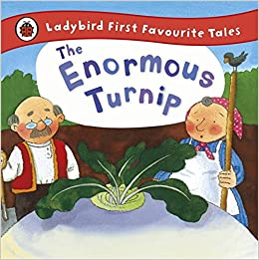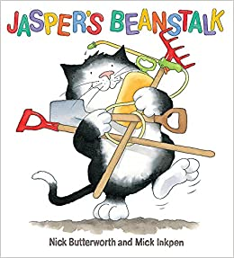

**Literacy**

* Key text – Jasper’s Beanstalk
* Key text – The Enormous Turnip
* Oral segmenting and blending to write and read independently.
* Phase 3 phonics.
* Introduce phase 4 sounds.
* Listening to and talking about stories with each other.
* Guided reading – talking about stories, characters and settings
* Guided reading – reading words and sentences independently.
* Recognising digraphs and trigraphs in word and knowing how to write them.
* Handwriting
* Outdoor environmental writing
* Writing sentences for a purpose.
* Independent writing in provision.
* Reading and writing tricky words.

**Expressive Arts & Design**

* Painting/drawing/play dough.
* Choosing certain colours – experiment with what happens when we mix colours.
* Manipulating and changing materials to create pictures and models.
* Using a variety of tools and materials to create our models and pictures.
* Role play- Garden Centre.
* Small world play – acting our stories or narratives.
* Constructing with a purpose in mind – changing and adapting models where necessary.
* Focussed creative activities teaching new techniques.

**Communication & Language**

* Listen in a range of situations, both to their friends and during whole class and focused activities.
* Respond to stories with relevant comments, anticipating what may happen next and discussing what has already happened.
* Follow instructions carefully.
* Answer ‘how’ and ‘why’ questions about stories and their experiences.
* Use language as an effective form of expression.
* Use language they have learnt when speaking.
* Use all tenses correctly when talking about their experiences.
* Develop and act out narrative and stories.

**Understanding the World**

* HeartSmart
* Changing seasons – Spring – what happens in Spring? Making observations about plants and animals.
* Using the iPads – educational games.
* Using the iPads to record ourselves.
* Plating and growing seeds.
* How have we changed from being a baby? How will we change as we get older?
* Talking about our experiences.

**Topic Enhancements/Diary Dates**

Planting seeds and watching them grow.

Looking at photographs of us at different stages in life.

Art afternoon.

DT afternoon.

Father’s Day cards.

Remember, please check Tapestry regularly and reading books are changed every Monday and Thursday. Please read at least 5 times in a week.

SCHOOL CLOSED 6TH MAY, 7TH JUNE

**Mathematics**

* Registration - How many children are here today? How many are away? How many left?
* Recognising numbers to 20.
* Counting reliably beyond 10.
* Counting out up to 10 or more objects.
* Addition and subtraction using objects, number lines etc.
* Naming and describing 2D shapes.
* Naming and describing 3D shapes.
* Using the language of time and recording time in simple ways.
* Talking about the height or length of objects.
* Ordering numbers to 20.
* Creating patterns.