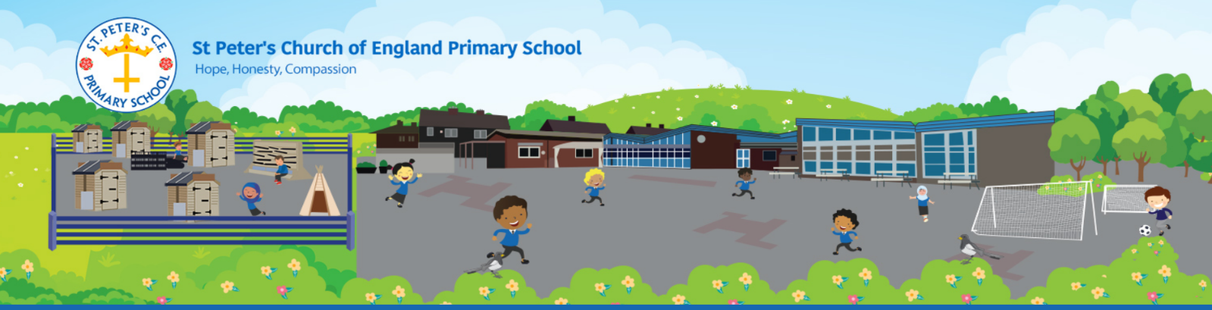
NEWSLETTER – May 2021

FACEBOOK
We have joined Facebook! Please like/follow us at St Peters CE Primary Bury for all the most recent updates. Each class aims to post at least once a week to show you the parent’s/carers what they have been up to.
ART WEEK
During Art Week each year group have been looking at a different artist, genre of art or area of interest. Have a look at our Facebook page for more.
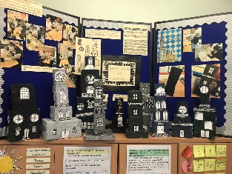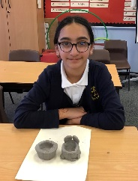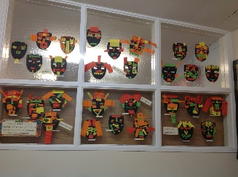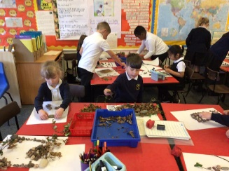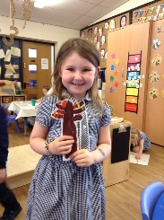

DT WEEK
During DT Week each year group have looked at a range of aspects within design technology. Have a look at our Facebook page for more information.
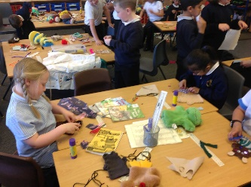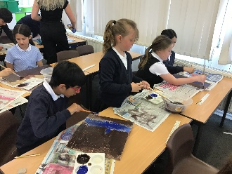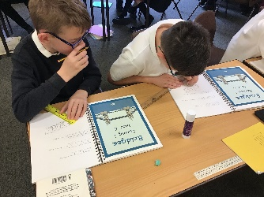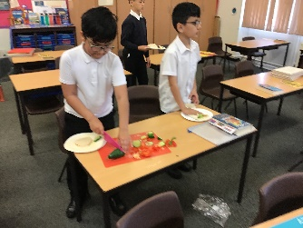

JAR OF JOY
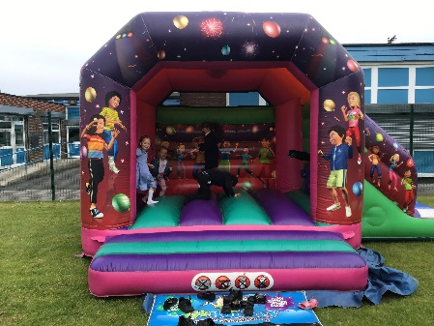
Throughout the school we run a reward scheme ‘The Jar of Joy’. This is where the children can receive pom-poms for a range of positive reasons; work, behaviour, manners etc. Once the jar has been filled the class are given a reward. This half term the children were working towards earning ice cream and a bouncy castle!
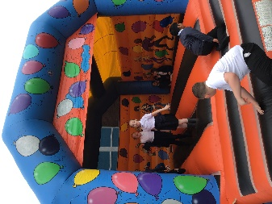

CONGRATULATIONS TO MRS RUSHTON!
Mrs Rushton is due to have a baby in a few weeks and she is starting her maternity leave today. We wish her all the very best of luck and we will miss her while she is off work. We look forward to meeting her baby when the time comes!

WARMER WEATHER
Once we return for our final half term, we will hopefully begin to see some warmer weather. We would like to ask that you apply sun cream to your child(ren) before sending them to school, when needed. They are also allowed to bring a cap or sun hat to wear (whilst outside). In addition, we also ask that you send your child in with a water bottle each day as we are unable to use the water fountains due to Covid restrictions.

NURSERY INTAKE – SEPTEMBER 2021
If you have a child born between 1 September 2017 – 31 August 2018 and you have not yet registered for a nursery place please speak to the school office.

ESCHOOLS
As you know we have been using eschools for text messages and letters (via email) for some time now for all our correspondence to parents and carers. It is essential that mobile numbers and email addresses are kept up to date. Please let the school office know by email – stpeters@bury.gov.uk or telephone 0161 764 2017 if your mobile or email address changes.

CORONA VIRUS
In the event your child develops any symptoms of Corona Virus (temperature, continuous cough or loss of smell or taste) please ensure you arrange a test as per government guidelines.
If symptoms develop within 48 hours of being in school (up to Sunday evening) 30th May then please email the school: stpeters@bury.gov.uk or leave a voicemail.
If your child develops symptoms from Monday 31st May onwards you do not need to notify school that your child is being tasted as NHS Track and Trace will deal with this.
However, please do let us know if your child tests positive of has to isolate doe to close contact.

IMPORTANT DATES
Enjoy your break, we will see you on Tuesday 8th June.
28th May | School Closes 3:15pm
8th June | School Opens
14th June – 18th June | Assessment Week
5th July -9th July | Y6 Bikeability
12th July | Y6 Crucial Crew
14th July | Y5 Road Safety
16th July | Reports to Parents
21st July | School Closes 3:15pm
2nd September | School Opens

